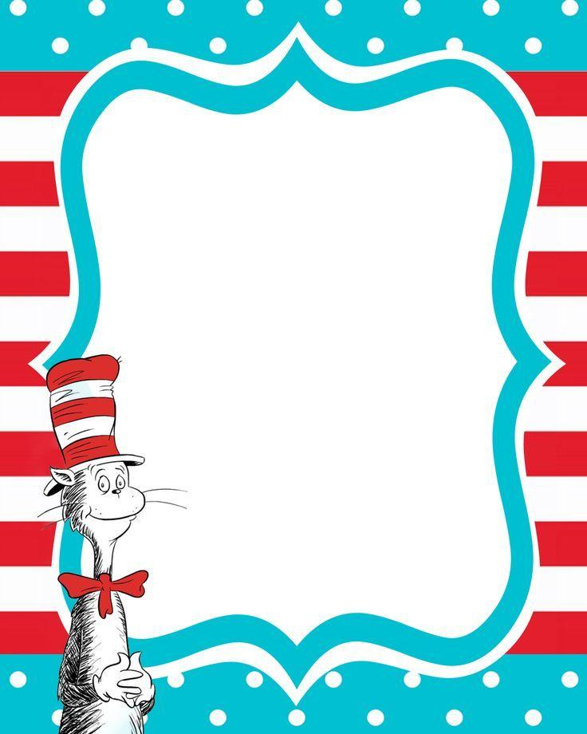

Monday - “Fox in Socks”

Wear silly or mismatched socks.

Tuesday - “Green Eggs and Ham”

Wear the color green.

Wednesday - “Wacky Wednesday”

Let’s get silly! Wear your clothes backwards, inside out, or mismatched.

Thursday - “The Cat in the Hat”

Wear your favorite hat.

Friday - “Sleep Book”

Wear your favorite pajamas and

bring in your favorite stuffed animal.

JHES’ Read Across America Spirit Week

February 25th - March 1st, 2019